QUESTION 1

TASK 2 JAVA

**-Write a Java program to read two integer variables and display the result of adding, subtracting, multiplying and dividing them**

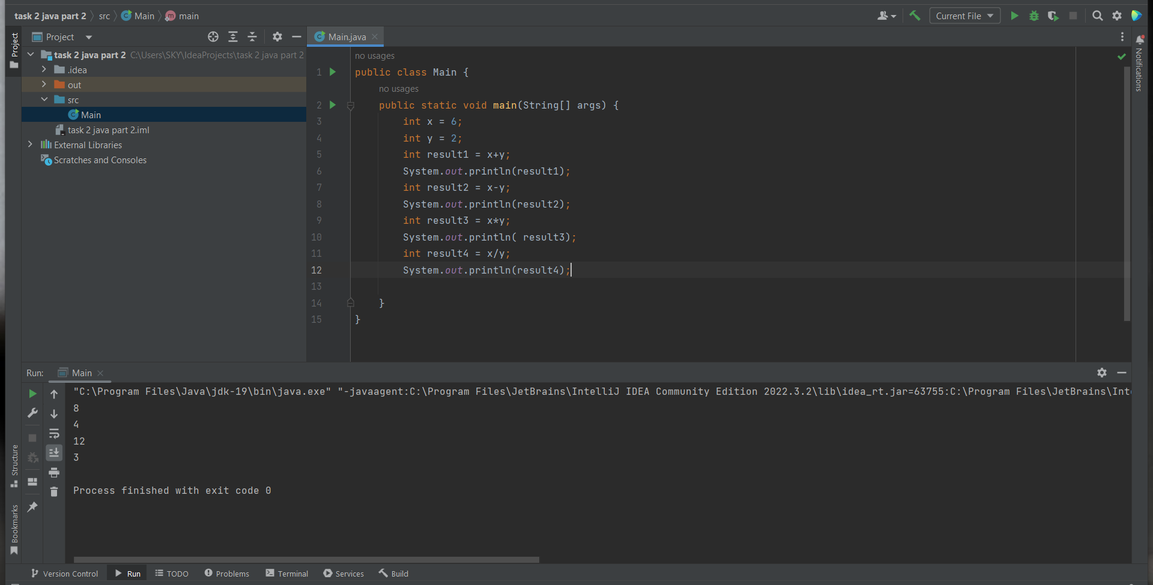

QUESTION 2

**-What is the value of the following expression?**

**int x = 5;**

**int y = 10;**

**int z = 15;**

**((x + y) * z) / (x - y)**

